

Name: Harrum Fatima Khan
Roll no: SU92-BSAIM-F23-123
Section: AI 4B

Task 11:

Lang Chain  LangChain is an open source framework that enables software developers working with artificial intelligence (AI) and its machine learning subset to combine large language models with other external components to develop LLM-powered applications.  LangChain aims to link powerful LLMs, such as OpenAI's GPT-3.5 and GPT-4, to an array of external data sources to create and reap the benefits of natural language processing (NLP) applications. It's also used for creating interfaces that produce humanlike responses and answer questions.  Developers, software engineers and data scientists with experience in Python, JavaScript or TypeScript programming languages can use LangChain packages offered in those languages.  LangChain was released in 2022 as an open source project by co-founders Harrison Chase and Ankush Gola.  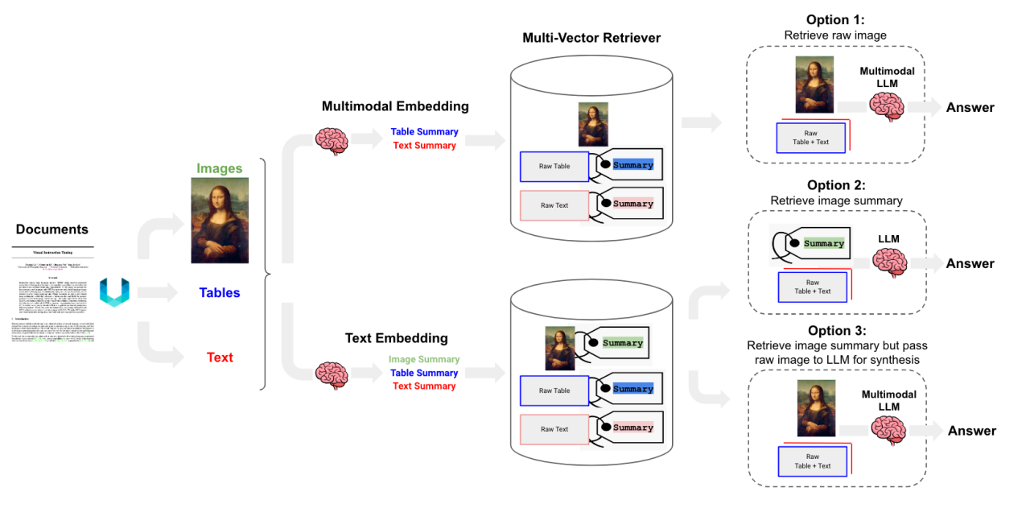  LLM  A large language model (LLM) is a type of machine learning model designed for natural language processing tasks such as language generation. LLMs are language models with many parameters, and are trained with self-supervised learning on a vast amount of text.  The largest and most capable LLMs are generative pretrained transformers (GPTs). Modern models can be fine-tuned for specific tasks or guided by prompt engineering. These models acquire predictive power regarding syntax, semantics, and ontologies inherent in human language corpora, but they also inherit inaccuracies and biases present in the data they are trained in.  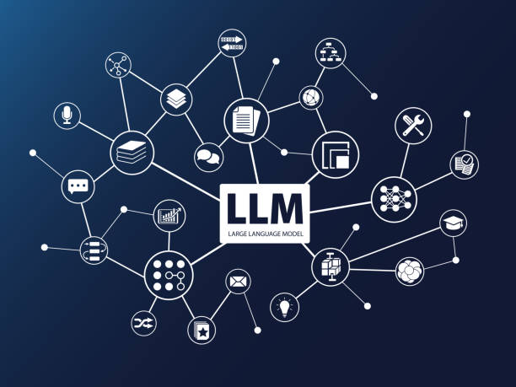  Vector  A vector is a mathematical approach for expressing and organizing data. The vectorization of data, such as word vectorization, is one of the initial phases in the creation of an ML model. In natural language processing, Word2Vec is a well-known ML model.  When represented data is in vector forms, it is simple and effective to employ all tools available in linear algebra for other tasks like model training or data augmentation. Machines are not human-like in their ability to comprehend text or view images. Input must thus be changed or encoded into numbers or a machine-readable format.  Inputs like text and pictures are represented as vectors and matrices, which allows machine learning or deep learning models to be trained and deployed.  Generative AI  Generative AI, sometimes called gen AI, is artificial intelligence (AI) that can create original content such as text, images, video, audio or software code in response to a user’s prompt or request.  Generative AI relies on sophisticated machine learning models called deep learning models algorithms that simulate the learning and decision-making processes of the human brain. These models work by identifying and encoding the patterns and relationships in huge amounts of data, and then using that information to understand users' natural language requests or questions and respond with relevant new content. | RAG  Retrieval-augmented generation (RAG) is a technique that enables generative artificial intelligence (Gen AI) models to retrieve and incorporate new information. It modifies interactions with a large language model (LLM) so that the model responds to user queries with reference to a specified set of documents, using this information to supplement information from its pre-existing training data. This allows LLMs to use domain-specific and/or updated information. Use cases include providing chatbot access to internal company data or generating responses based on authoritative sources.  RAG improves large language models (LLMs) by incorporating information retrieval before generating responses. Unlike traditional LLMs that rely on static training data, RAG pulls relevant text from databases, uploaded documents, or web sources. According to Ars Technica,  "RAG is a way of improving LLM performance, in essence by blending the LLM process with a web search or other document look-up process to help LLMs stick to the facts."  This method helps reduce AI hallucinations, which have led to real-world issues like chatbots inventing policies or lawyers citing nonexistent legal cases.  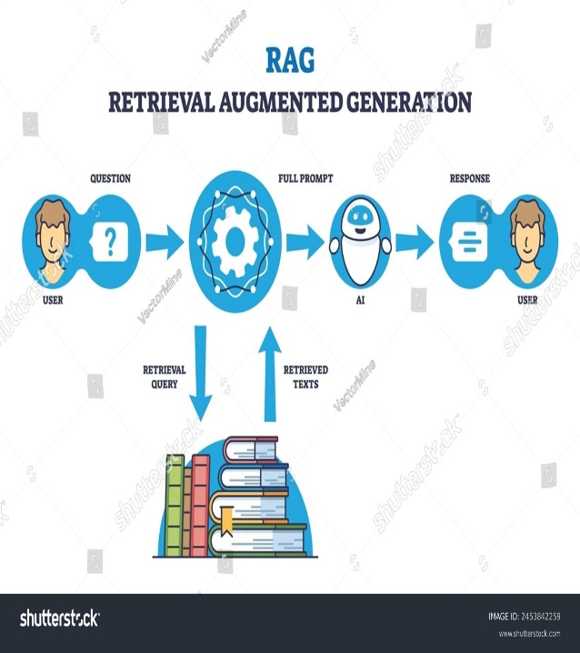  FAISS  Faiss, short for Facebook AI Similarity Search, is an open-source library built for similarity search and clustering of dense vectors. Faiss can be used to build an index and perform searches with remarkable speed and memory efficiency. Additionally, it enhances search performance through its GPU implementations for various indexing methods.  Traditional search engines do a good job of finding exact matches, but they often fall short when it comes to identifying similar items based on content like images, videos, or text. This limitation can hinder the development of applications such as recommendation systems, image searches, and anomaly detection systems.  To overcome this, Meta AI (formerly Facebook AI) developed Facebook AI Similarity Search (Faiss).  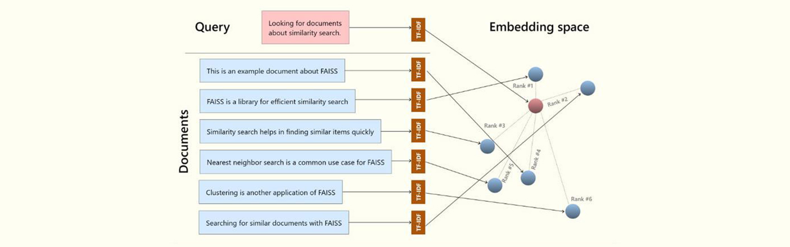  Vector DB  Information comes in many forms. Some information is unstructured—like text documents, rich media, and audio—and some is structured—like application logs, tables, and graphs. Innovations in artificial intelligence and machine learning (AI/ML) have allowed us to create a type of ML model—embedding models. Embeddings encode all types of data into vectors that capture the meaning and context of an asset. This allows us to find similar assets by searching for neighboring data points. Vector search methods allow unique experiences like taking a photograph with your smartphone and searching for similar images.  Vector databases provide the ability to store and retrieve vectors as high-dimensional points. They add additional capabilities for efficient and fast lookup of nearest-neighbors in the N-dimensional space. They are typically powered by k-nearest neighbor (k-NN) indexes and built with algorithms like the Hierarchical Navigable Small World (HNSW) and Inverted File Index (IVF) algorithms. Vector databases provide additional capabilities like data management, fault tolerance, authentication and access control, and a query engine.  GANS  A generative adversarial network (GAN) is a class of machine learning frameworks and a prominent framework for approaching generative artificial intelligence. The concept was initially developed by Ian Goodfellow and his colleagues in June 2014.^{[1]} In a GAN, two neural networks compete with each other in the form of a zero-sum game, where one agent's gain is another agent's loss.  Given a training set, this technique learns to generate new data with the same statistics as the training set. For example, a GAN trained on photographs can generate new photographs that look at least superficially authentic to human observers, having many realistic characteristics. Though originally proposed as a form of generative model for unsupervised learning, GANs have also proved useful for semi-supervised learning,^{[2]} fully supervised learning,^{[3]} and reinforcement learning.^{[4]}  The core idea of a GAN is based on the "indirect" training through the discriminator, another neural network that can tell how "realistic" the input seems, which itself is also being updated dynamically.^{[5]} This means that the generator is not trained to minimize the distance to a specific image, but rather to fool the discriminator. This enables the model to learn in an unsupervised manner.  GANs are similar to mimicry in evolutionary biology, with an evolutionary arms race between both networks.

